Necessary Policies and Documents
Policy or Document | Required by law/IRS | Purpose | Chapter has?
Articles of Incorporation | Required | Established existence; filed with IRS.
Bylaws | Required | Defines how organization is run; how members interact with each other and association.
Compensation Policy | Required | Part of Form 990, part VI – salary, retirement plan contributions, deferred compensation, health benefits, PTO.
Conflict of Interest | Required | Part of 990, Part VI. How to identify, disclose and deal with situations where there is financial or other conflict. Sample provided below.
Document Retention/Destruction | Required | Form 990, Part VI. States that association adheres to regular business practice of document destruction according to schedule. Sample provided below.
Mission Statement | Required | Articulates the purpose and reason for its existence.
Whistleblower Protection Policy | Required | Form 990, part VI, protect individuals who report activities believed to be illegal, dishonest, unethical or otherwise, improper. Sample provided below.
Antitrust | Good Governance | Prohibits contract, combinations in restraint of trade. Avoid agreements on prices, fees, and boycotts. Membership decisions must be based on published criteria (bylaws). (Can be part of Code of Ethics/Board Commitment Form.)
Apparent Authority | Good Governance | Guidance about who is authorized to make public statements on behalf of association. Also, how public statements should be handled. (Can be part of Code of Ethics/Board Commitment Form.) Sample provided below.
Code of Ethics | Good Governance | Outlines rules and responsibilities, or proper practices for members of the board. Sample provided below.
Confidentiality | Good Governance | Agreement to keep confidential matters confidential. (Can be part of Code of Ethics/Board Commitment Form.)
Investment Policy | Good Governance | Objectives for investing and risk tolerance. Sample provided below.
Personnel Handbook | Good Governance | Guidelines and summary information for employees.
Strategic Plan | Good Governance | Sets direction for association.
Travel and Entertainment Policy | Good Governance | What expenses will be reimbursed and the process.
Board commitment form or Code of Ethics could incorporate many including Apparent Authority and Confidentiality.

Addendum 1: Current Policies (Samples)

Conflict of Interest Policy
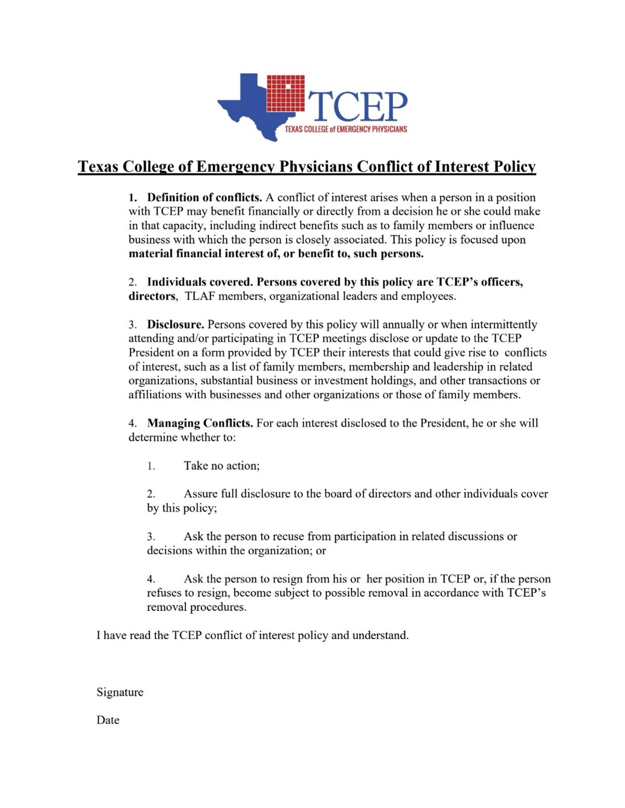s
Long-Term Investment Policy

Purpose: Create a long-term fiscally responsible investment strategy which will both outperform inflation and grow the assets of the college with an acceptable risk profile.

Strategy: In October 2019 the board adopted a plan to invest in two low-cost well diversified index funds through Vanguard. The board was presented with different asset allocations between equities and bonds and settled on an 80/20 equities to bonds ratio. According to Vanguards historical research these unprotected investments should yield returns of 9.4% when averaged over the long-term (see graphic below). Additionally, TCEP would maintain approximately one year of operating expenses in protected investments (money market funds and checking accounts), of which 30-60 days of operating expense funds would be held in the checking account.

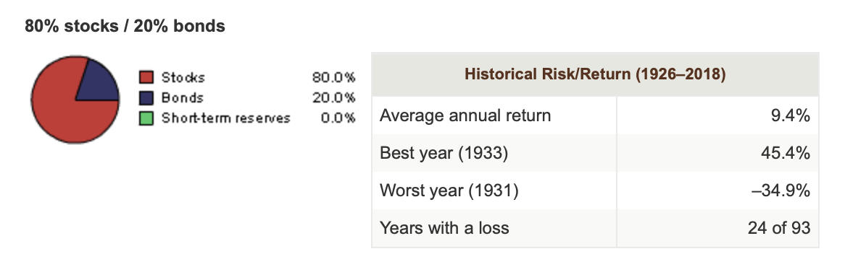

In July 2020 it was noted that interest rates on the money market funds had dropped to negligible levels, prompting the Board to divert a portion of the money market fund into the bond index fund to achieve better returns with similar risks. The Board decided to re-allocate to the following model:
Domestic stock indexed mutual fund 55%
Domestic bond indexed mutual fund 30%
Money market fund 15%
Continue to maintain 30-60 days of operating expenses in a checking account.

According to Vanguards historical research this allocation (now including the money market fund as part of the allocation) should yield returns of 8.2% when averaged over the long-term (see graphic below).

Process: On a quarterly basis, and any other time it is deemed necessary based on market conditions, the Finance Committee Chair will report the status of the investments to the Treasurer, which will include an analysis of the asset allocation. If the allocation deviates from the approved model more than 5%, the Treasurer will notify the executive committee with a recommendation for possible asset re-allocation to the approved model.

Any changes to the asset allocation model or any reallocation to correct a deviation must be approved by the [insert chapter] Executive Committee or the [insert chapter] Board of Directors.

Additional information: The 501 (c) (6) status of the college eliminates tax liabilities on income from these investments.

Approved: [insert date] – [insert chapter] Board of Directors

TCEP Record Retention Policy
This policy pertains to the retention and destruction of documents and other records. The policy provides guidance for the:
- Retention and maintenance of documents necessary for the proper functioning of the organization as well as to comply with applicable legal requirements.
- Destruction of documents which no longer need to be retained; and
- Responsibilities for the Board of Directors, Officers, staff and other individuals with respect to document retention and destruction.
Records and documents outlined in this policy include paper, electronic files (including e-mail) regardless of where the document is stored, including network servers, desktop or laptop computers and handheld computers. Documents in electronic format shall be maintained just as hard copy or paper documents are in accordance with the Document Retention Schedule below.
The Executive Director shall coordinate the retention and destruction of documents pursuant to this policy and particularly the Document Retention Schedule included below.
Documents shall be stored in a safe and accessible manner. Documents which are necessary for the continued operation of the organization in the case of an emergency shall be regularly duplicated or backed up and maintained online. The Executive Director shall develop reasonable procedures for document retention in the case of an emergency.
Document Retention Schedule
Type of Document | Minimum Requirement
Accounts Payable ledgers and schedules | 7 years
Accounts receivable ledgers and schedules | 7 years
Articles of Incorporation | Permanently
Bank reconciliations | 2 years
Bank statements | 7 years
Budgets | 7 years
Bylaws | Permanently
Checks (for important payments and purchases) | Permanently
Checks | 7 years
Contracts, notes, loans and leases | 7 years after expiration
Correspondence (legal and important matters) | Permanently
Financial Statements (Year-end) | Permanently
Grants (funded) | 7 years after completion
Insurance records | Permanently
Insurance policies (expired) | 3 years
Invoices (to customers, from vendors) | 7 years
IRS Exemption Determination Letter – 501 (C)(6) | Permanently
Legal case file (notice of claim, complaint, investigative logs, court orders, motions, notes, briefs | 7 years after case closed
Licenses and permits | Permanently
Minutes of Meetings | Permanently
Secretary of State reports | Permanently
Strategic Plans | 10 years after expiration
Tax Returns and Worksheets | Permanently

TCEP BOARD MEMBERS' CODE OF CONDUCT / ETHICS

The Board expects its members to behave with ethical and businesslike conduct. This commitment includes proper use of authority and appropriate decorum in group and individual behavior when acting as Board members.
Board members must represent unconflicted loyalty to the interests of the association. This accountability supersedes any conflicting loyalty such as that to advocacy or interest groups and membership on other Boards or staffs.
Board members must avoid any conflict of interest with respect to their fiduciary responsibility.
a. There must be no self-dealing or any conduct of private business or personal services between any Board member and the organization except as procedurally controlled to assure openness, competitive opportunity and equal access to "inside" information.
b. Board members must not use their positions to obtain employment in the organization for themselves, family members or close associates.
c. Should a Board member be considered for employment, the Board member must temporarily withdraw from Board deliberation, voting, and access to applicable Board information.
Board members may not attempt to exercise individual authority over the organization except as explicitly set forth in Board policies.
Board members' interaction with the public, press or other entities must recognize the same limitation and the similar inability of any Board member or Board members to speak for the Board.
Board members will not disclose information that is deemed confidential.
Board members will notify the President and President-Elect of any perceived violations of the Code of Ethics.

APPARENT AUTHORITY DRAFT

Apparent Authority is the appearance of being the agent of another with the power to act for the principal. Since under the law of agency the employer/principal is liable for the acts of his employee/agent, if a person who is not an agent appears to an outsider to have been given authority by the principal, then the principal is stuck for the acts of anyone he allows to appear to have authority. This can arise when a Board member, though not granting actual authority, permits a committee or chapter to behave as if it has authority. Authority should rest with the TCEP President and may be assumed by other agent of the organization if approved by President.

WHISTLEBLOWER POLICY SAMPLE

PURPOSE
The Texas College of Emergency Physicians (“TCEP”) is committed to high standards of ethical, moral and legal business conduct. In line with this commitment and TCEP’s commitment to open communication, this policy aims to provide an avenue for employees to raise concerns and reassurance that they will be protected from reprisals or victimization for whistleblowing. This Whistleblower Policy is intended to cover protections for you if you raise concerns regarding TCEP, such as concerns regarding:
• incorrect financial reporting;
• unlawful activity;
• activities which otherwise amount to improper conduct.
STATEMENT OF POLICY
No officer, director, employee or agent of TCEP shall take any harmful action with the intent to retaliate against any person, including interference with employment or livelihood. Nor will any officer, director, employee or agent take any harmful action with intent to retaliate against any employee or member of TCEP for reporting the suspected misuse, misallocation or theft of any TCEP resources.
SAFEGUARDS
Harassment or Victimization - Harassment or victimization for reporting concerns under this policy will not be tolerated.
Confidentiality - Every effort will be made to treat the complainant’s identity with appropriate regard for confidentiality.
Anonymous Allegations - This policy encourages employees to put their names to allegations because appropriate follow-up questions and investigation may not be possible unless the source of the information is identified.
Concerns expressed anonymously will be explored appropriately, but consideration will be given to:
• The seriousness of the issue raised;
• The credibility of the concern; and
• The likelihood of confirming the allegation from attributable sources.
Bad Faith Allegations – Allegations made in bad faith may result in disciplinary action.
PROCEDURE
Process for Raising a Concern:
Reporting- The whistleblowing procedure is intended to be used for serious and sensitive issues. Such concerns, including those relating to financial reporting or unethical or illegal conduct, may be reported directly to: [name, title, telephone number, address, email address]. Employment-related concerns should continue to be reported through your normal channels such as your supervisor, or Executive Director.

Timing - The earlier a concern is expressed, the easier it is to take action.

Evidence - Although the complainant is not expected to prove the truth of an allegation, he or she should be able to
demonstrate to the person contacted that the report is being made in good faith.
How the Report of Concern Will Be Handled:
The action taken by TCEP in response to a report of concern under this policy will depend on the nature of the concern. The Executive Committee? of the TCEP Board of Directors shall receive information on each report of concern and follow-up information on actions taken.
Initial Inquiries - Initial inquiries will be made to determine whether an investigation is appropriate, and the form that it should take. Some concerns may be resolved without the need for investigation.
Further Information -The amount of contact between the complainant and the person or persons investigating the concern will depend on the nature of the issue and the clarity of information provided. Further information may be sought from or provided to the person reporting the concern.
For additional information, contact Executive Director to receive reports].

TCEP reserves the right to modify or amend this policy at any time as it may deem necessary.
ADOPTED ON: _____________________

